Byron Laferriere
Professor Gupta
DAD-220
21 June 2020

Final Project Two

The queries run in this report will help management highlight focus areas to improve during production. The product manager will be able to clearly view which products are being returned the most, as well as problematic states for certain products. The first query run returns the frequency of returns by state, grouped together. The second query used isolated each product that was returned and the frequency of it being returned. These results will allow management to decide how to move forward in the future with products being manufactured.
The first query examined returns completed by state. The top five states in descending order were Georgia (.6262), Massachusetts (.5678), New Jersey (.3912), Kentucky (.3356), and Texas (.2233). This could highlight possible manufacturing issues or shipping issues to these specific areas. Also, there could machine issues outside of your control in these areas that is causing the products to malfunction.
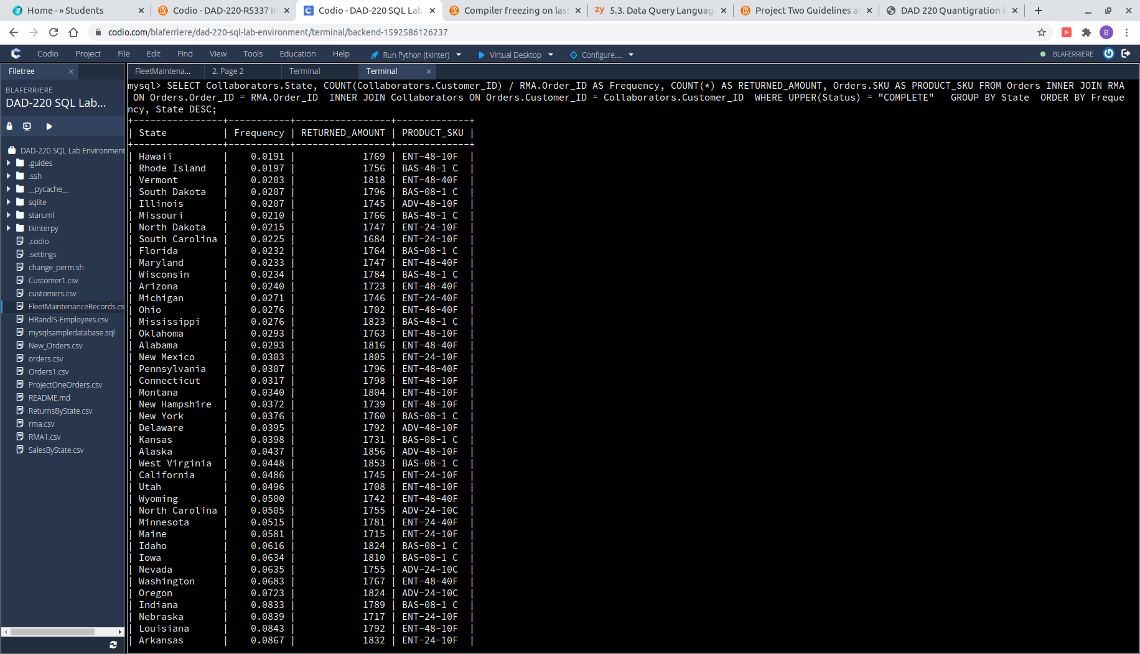
The second query used in this report isolates each product being returned and counts the frequency of return for each product. These results will be useful in combination with the first query, in helping management better understand exactly which products are being returned per state. We will use Georgia, which had the highest return rate, as an example in showing how this second query will bring more insight to returns. Management will now be able to see instantly what is being returned, and at the rate it is being returned. Allowing them to decide how to move forward with certain product production.
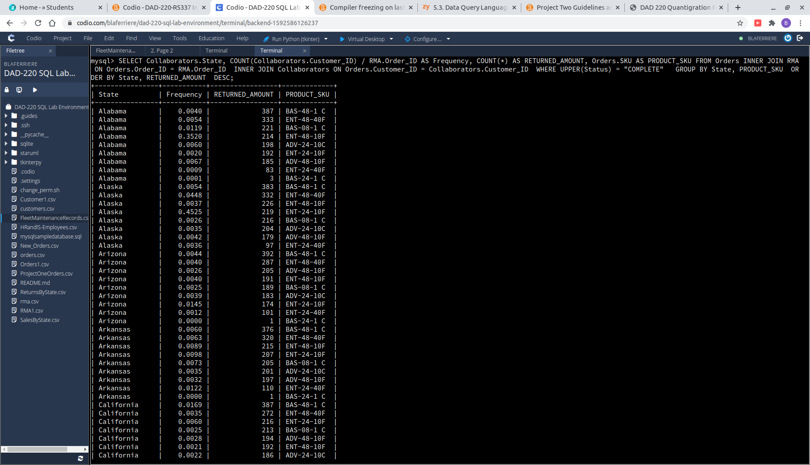
| Georgia | 0.0288 | 427 | BAS-48-1 C |
| Georgia | 0.0087 | 278 | ENT-48-40F |
| Georgia | 0.0722 | 200 | BAS-08-1 C |
| Georgia | 0.0023 | 191 | ENT-24-10F |
| Georgia | 0.0037 | 189 | ADV-24-10C |
| Georgia | 0.0024 | 186 | ADV-48-10F |
| Georgia | 0.0109 | 161 | ENT-48-10F |
| Georgia | 0.0118 | 97 | ENT-24-40F |
| Georgia | 0.0001 | 5 | BAS-24-1 C |

The problem with using data retrieved in this manner is the lack of information regarding the causation of return. Return status’ don’t highlight whether it was a manufacturing issue or a customer mechanical issue. This would provide a more accurate sense of product failure for the management team. Making future company decisions off of this data would be ill-advised due to this lack of information. A further investigation into these return reasons would be advised.
In conclusion, there are too many limitations currently present to make decisions based off this information. Limitations like return reason and completion status were not taken into consideration. Steps like ‘Awaiting Customer Documentation’ should have also been considered in the returns, because the product had still faulted out – even though the customer has not been able to complete the process. This would provide a more complete picture of returns being processed and include all customer cases with product issues. Another angle that could be used in examining company performance for improvement, is the combination of information regarding the returns by region. Obtaining a percentage or frequency of product returns by region, would help provide a better understanding that management could use to improve customer satisfaction regionally. The data provided here should encourage a further investigation in returns and their causation.

